Add release date

The World Heart Federation’s World Congress of Cardiology & Cardiovascular Health 2018 returns to Dubai to tackle the number 1 killer
- Cardiovascular disease (CVD) is the number one cause of death around the world, despite the fact that premature mortality from CVD is largely preventable
- Experts will convene at the World Heart Federation’s World Congress of Cardiology and Cardiovascular Health (WCC) 2018 in Dubai, 5-8 December 2018, to inspire action

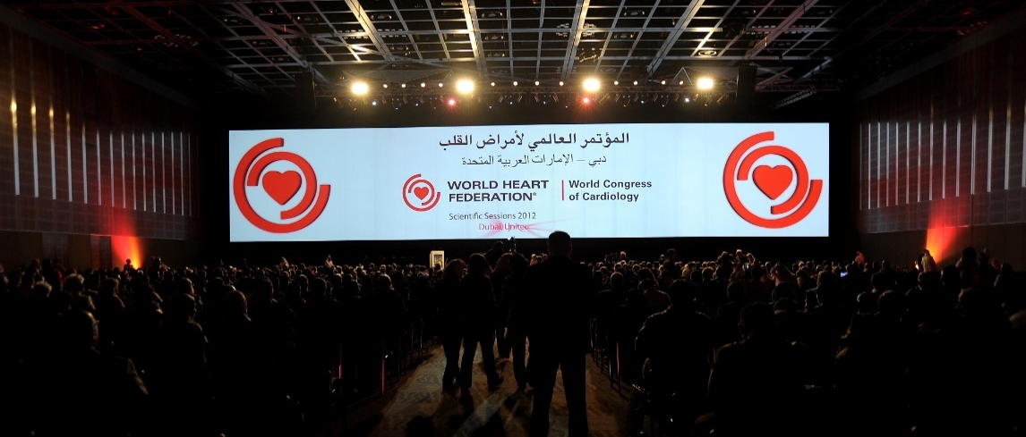

The 2012 World Congress of Cardiology & Cardiovascular Health held in Dubai saw health professionals participate in over 150 sessions and workshops. Since then, Dubai has seen the growth and integration of global scientific and health leadership to meet the new health challenges in the region namely the continuing use of tobacco, the rise in obesity rates and the corresponding increase in the prevalence of diabetes all contributing to the emerging burden of circulatory diseases.
Cardiovascular diseases (CVD) such as heart attack and stroke are responsible for over 17.7 million deaths each year worldwide, representing 31% of all global deaths. This is a critical moment in the history of the cardiovascular (CV) epidemic when the opportunities for a sustainable impact on CV health has never been greater. That is why the researchers, cardiologists, policymakers and health leaders from around the world will convene at WCC 2018 in Dubai, 5-8 December, to highlight the challenges of tackling CVD, and to showcase ground-breaking research, new technological advances and practical examples of how interventions from around the world can be implemented in various settings to save lives.
Professor David Wood, President of the World Heart Federation, declared: “We look forward to welcoming you to Dubai to the World Congress of Cardiology & Cardiovascular Health 2018, held in partnership with the Emirates Cardiac Society and the Gulf Heart Association, with whom we are putting together an exciting programme for cardiologists, internal medicine specialists, generals practitioners, nurses and allied health professionals.”
Professor Jagat Narula, Chair of the WCC 2018 Congress Programme Committee: “we are very excited to convene the cardiovascular community at the WCC 2018. The interactive scientific programme will be presented by world renowned leaders in heart health, and will include the latest developments in cardiology and cardiovascular health.”
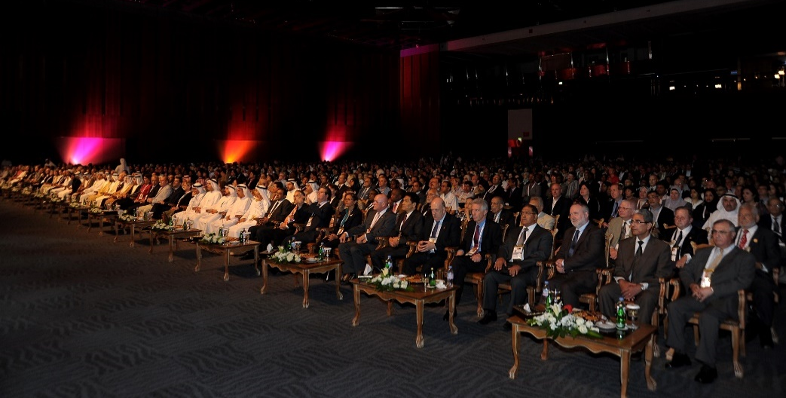
Ends

Notes to editors

Registration for journalists at WCC 2018 is free.
- To register for your free place at Congress contact: wcc2018reg@mci-group.com
- To sign up to receive press materials or for more information contact: congress@worldheart.org

About WCC 2018
The World Congress of Cardiology & Cardiovascular Health (WCC) 2018 is taking place in Dubai, 5-8 December 2018. It is the official congress of the World Heart Federation and it is an international forum, showcasing experts from across the globe and convening the whole cardiovascular community to discuss and implement innovative solutions on heart health and the latest developments in cardiology. For more information about WCC 2018 including the scientific programme visit the website.

About the World Heart Federation
The World Heart Federation is dedicated to leading the global fight against cardiovascular disease (CVD), including heart disease and stroke. We are the only global advocacy and leadership organization bringing together the CVD community to drive the CVD agenda and help people live longer, better, more heart-healthy lives. Working with more than 200 member organizations in over 100 countries, the World Heart Federation is dedicated to leading the global fight against cardiovascular disease (CVD), including heart disease and stroke. For more information, please visit:
www.worldheart.org
www.facebook.com/worldheartfederation
twitter.com/worldheartfed

http://www.who.int/mediacentre/factsheets/fs317/en/ (figure from 2015)
http://www.ecsociety.com/en.html
http://gulfheart.org/

