Cardiovascular Prevention in the Comarca Andina of the Parallel 42
(English version)

César Berenstein
MT SAC

Cardiovascular Prevention Project in the Comarca Andina of the Parallel 42.
Introduction
El Bolsón is a small city, located in the mountain chain of Río Negro province, Patagonia Argentina. It is part of an area, shared with the province of Chubut, known as Comarca Andina of the Parallel 42 where smaller towns like Lago Puelo, Epuyén, El Maitén, Ñorquinco, El Hoyo and Cholila are located. It is surrounded by a vast rural area that dedicates to the agriculture activity with small farms and organic vegetable gardens in which hop, berries and different kind of vegetables are grown, and where immigrants and different ethnic groups like mapuches and other native groups coexist. Despite being a fruit and vegetable producer province the fruit and vegetable consume, according to the 3º National Survey of Risk Factors, was less than the Argentinean average in that aspect (1). On the other hand there is a census of high level of obesity in the younger groups of the population.

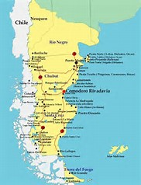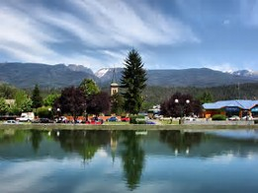
Comarca Andina of the Parallel 42

Background:
I am Dr. César Berenstein, MT SAC, member of the scientist committee of the 43º Argentinean Cardiology Congress, former member of Directive Commission of the Argentinean Cardiology Society (SAC).
I lived twelve years in Ushuaia, the most southern city of the country, where I run a prevention campaign called “Know yours numbers Ushuaia” from the year 2007 up to 2012. With this campaign and thanks to the media involvement more than 1500 people, 5% of the elderly population, were controlled. The alarming results, due to the amounts of obesity and the low physical activity, where useful as warning for the people to change their life habits.
Since 2015 I live in the city EL Bolsón, where I practice as a cardiologist in the private field, with special interest in reaching the community with prevention messages and in the realization of simple research works on local investigations that were presented in national congresses and one of the them was recently published in the Argentinean Cardiology Magazine about adherence to antihypertensive treatment. (3)

Cardiovascular prevention in the Comarca Andina of the Parallel 42
The aim of this project was to reach massively the community with a message of prevention mainly oriented to the improvement of their life habits with healthy behaviors and to reach all the social groups with different ways. There is no budget for the activities, neither institutions that support it, but a vocational incentive and the spirit of giving back to the community the opportunity of being part.
- Radio program “The Doctor arrived”
It is a weekly program emitted by FM Patagonia Andina of El Bolsón since the year 2015. It already has 120 programs in the air. It is repeated in other towns of the Comarca Andina (Epuyén, El Maitén y Ñorquinco) and in other places of the country (Monteros in the province of Tucumán, Cordoba City and Villa Dominguez in the province of Entre Ríos). The theme is related to medicine with an informal vision, specialists from the whole country and worldwide are interviewed by telephone with a prevention message and the eagerness of improving the life quality of the population with vocabulary for everybody.

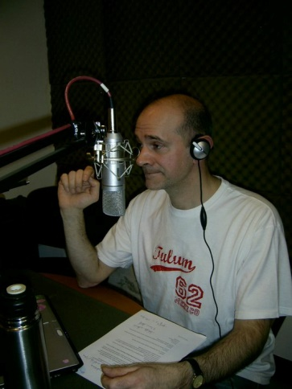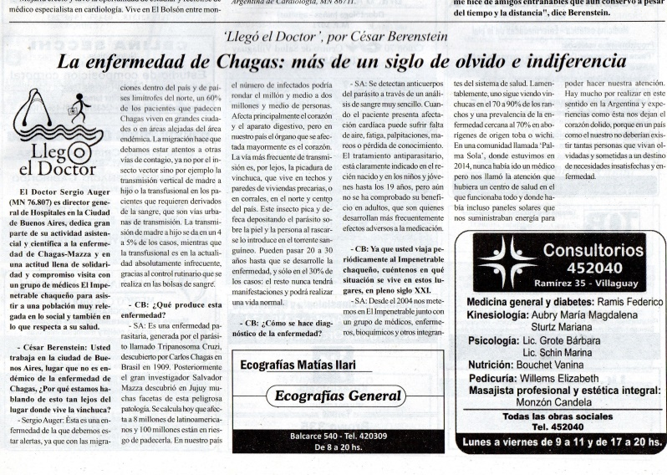
Media participation to reach the community with prevention message

- Activities in graphic media: Health Column “The Doctor arrived”
I write notes of medical interest in newspapers, reproducing the radio interviews or writing notes of opinion. These notes are published in the newspapers “El Bolsonés”, from El Bolsón and in “El Pueblo” from the city of Villaguay, Entre Ríos province.

- Activities in Institutions:
I make talks to the community in different scenarios that are based on a simple message adapted to the different ages and levels of instruction. By different means I try to break the ice with funny acts and songs that I create together with musicians’ friends that have relation with the content of the talks, with these songs I defeat the inhibition of the public and made them ask all their doubts. Las year I made meetings in primary schools, primary schools for adults in the Mapuche population, Universidad Nacional de Río Negro, Retired centers in Bariloche (Río Negro) and Villa Dominguez (Entre Ríos) and in the IIº Congress for the community in the Colón Theater of Mar del Plata (Buenos Aires province).
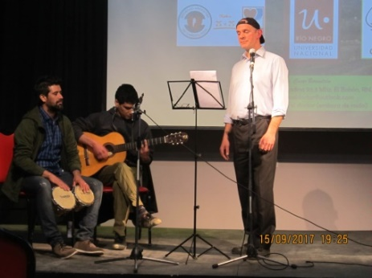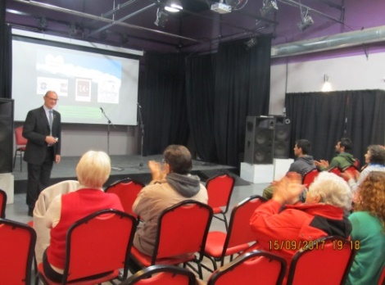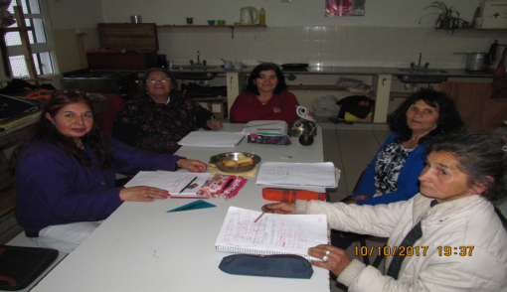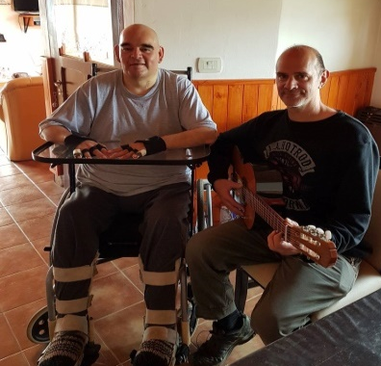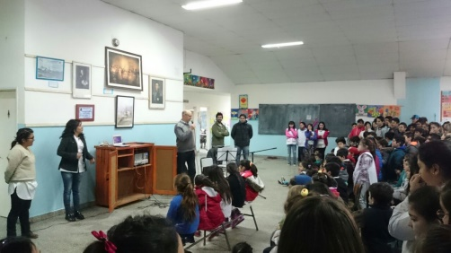
Funny educational activities to the community

- Participation in the campaign “25 by 25 project”
Taking advantage of the radio listeners I made, with help of the radio staff, advertisements about this campaign to achieve a 25% reduction in cardiovascular premature deaths by 2025 proposed by the World Health Organization and the SAC. (4) It was also part of a theme in the talks with the community and in the radio interviews so the population of the Comarca Andina becomes conscious about this topic.

- “Woman and heart” group
I was recently incorporated to the SAC group “Woman and heart”, where I had the chance to present in the context of the 43º Argentinean Cardiology Congress together with the AHA, my experience in the Patagonia related to this topic. We made advertisements with the radio staff and interviews to model doctors in this work group.

- Campaign “For dessert always a fruit”
Advertisements in the radio and graphics related to the benefits of adding a fruit in the dessert, what would assure at least two daily portions, that is above the average estimated in the National Survey of Risk Factors in the province.
New objectives:
To make a work of valuation of the cardiovascular risk of the municipality workers from El Bolsón and to generate trough information and access to healthier food, improvements of the risk factors of cardiovascular disease.
To take “Woman and heart” to places where women are gathered (weavers groups, school for adults, workshops for older people, etcetera) in set aside areas of the rural population like Ñorquinco, Cushamen and Pampa del Mallín.
To expand the arrival of the radio program to other populations of the country that are interested in the dissemination of the measurements of prevention for free.
A research work is ongoing in the Comarca Andina which surveys of risk factors on women that goes for pre-operative evaluations of other than cardiology surgerys are made in the cardiology office.
References:
- National Survey of Risk Factors. Ministry of Health of the Argentinean Republic, 2014.
- Campaign “Know your numbers Ushuaia I, II and III”: Prevailing risk factors in a population without cardiovascular disease. XXIV Interamerican Cardiology Congress, CABA 2013. Berenstein, CD et al.
- Relation between the level of adherence to treatment and the control of blood pressure in ambulatory patients. Register of arterial hypertension in the Comarca Andina of the Parallel 42 (REHTACAP 42). Rev Argent Cardiol 2017; 85 (3): 268-9. Berenstein, CD.
- 25 by 25 is not 625. SAC President’s letter. Rev Argent Cardiol 2017;85 (2): 181-2.

César Berenstein. Cardiólogo universitario UBA-SAC
MT SAC. M.N. 86711

