THE GOAL DECLARED BY THE COLOMBIAN MANIFESTO FOR THE PREVENTION OF MYOCARDIAL INFARCTION: REDUCING THE MORTALITY FOR INFARCTS BY 25% IN COLOMBIA FOR THE YEAR 2025

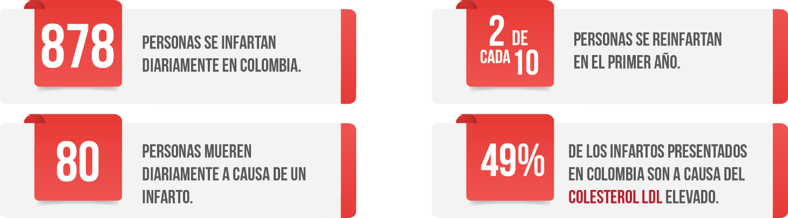
* 878 persons have heart attacks daily in Colombia. * 2/10 people have another event in the following year.
* 80 people die daily due to a heart attack. * 49% of the infarcts in Colombia are due to high LDL cholesterol.

Cardiovascular disease in Colombia leads to more than sixty thousand annual deaths, representing one in three deaths and making it the first cause of preventable death in the country. Among cardiovascular events, myocardial infarction is responsible for 29 thousand deaths, which on average represents 80 deaths every day. In Colombia, heart attacks are responsible for more deaths than all types of cancer combined.
Given this situation, the World Heart Federation, Colombian Society of Cardiology and Cardiovascular Surgery, Ministry of Health, Academy and Civil Society met to achieve the goal of reducing heart attacks in Colombia and establish actions for joint action to realize it. As a result of this meeting it was agreed that this commitment will reduce the mortality caused by heart attacks by 25% in Colombia for 2025.
This objective is aligned with the numbers of heart attacks caused by high cholesterol, since this risk factor produces 47.6% of the heart attacks registered annually. High cholesterol is the main cause of the development of cardiovascular disease. Of the 47.6% who suffer heart attacks, two out of ten people who survive experience another in less than a year.
On the other hand, and taking into account the economic outlook of cardiovascular diseases and their cost to the country, this interinstitutional agreement hopes to tackle the risk factors in order to prevent heart attacks and reduce costs for the treatment of cardiovascular disease. Cardiovascular disease costs Colombia $6.4 trillion annually and the health system takes care of approximately $3.84 trillion, which translates to a 6.55% allocation of the total expenditure on medical care for the treatment and costs $2.58 billion per year due to loss of productivity.

Despite the actions carried out to date, the results are not very promising. The social and economic burden grows annually, and the significant impact of CVD in Colombia requires a priority intervention in creating a public policy that modifies behavior and generates a societal commitment.
For this reason, the Colombian Manifesto Against Heart Attacks, led by the World Heart Federation, is committed to 7,000 fewer heart attacks per year in Colombia by the year 2025, for which it will develop three decisive actions inter-institutionally, to be implemented by June 2018:
- Creation of the National Registry of Infarctus in Colombia – Programa Bandera Roja
- Restructuring of Cardiac Rehabilitation in all of healthcare institutions programmes
- Priority implementation of cholesterol clinical guidelines for the management of high-risk patients in all IPS (Service Provider Institutions) in the country.
This agreement is a commitment from the main actors of the health system to encourage a public policy that leads to a reduction in mortality from cholesterol in Colombia and an improvement in patient quality of life and overall sustainability of the health system.
Through this plan of action, Colombia will be a model for the region in the prevention of heart attacks and a leader in the approach, follow-up and intervention of patients with high cardiovascular risk.

Mohan KM, Wolfe CD, Rudd AG, et al. Risk and cumulative risk of stroke recurrence: a systematic review and meta-analysis. Stroke. 2011;42(5):1489-1494

