Adherence to treatment. A key issue to reach 25 x 25 objectives.
Cardiovascular disease (CVD) remains a paramount cause of mortality globally. The treatment of CVDs has been unequivocally shown to positively impact patient-related outcomes leading to reductions in mortality, stroke and heart failure. (1)
The problem of non-adherence to cardiovascular medications is of high interest as it has a direct impact on the disease management, prognosis and patient’s quality of life.
WHO stated that treatment non-adherence is a major public health problem that may result in disease persistence. (2) A report by WHO estimated that the average rate of adherence to medication is around 50% among patients suffering from chronic diseases in developed countries and it is assumed to be lower in developing countries. (3)
Adherence and persistence are classified as two dimensions of behavior related to medicine intake. The term persistence is applied to describe the duration of time from initiation to discontinuation of drug therapy. Adherence describes all behaviors influencing patients’ outcomes, such as medicine-taking behavior, following dietary and lifestyle advice, vaccinations and obeying follow-up visits.
Consequently, non-adherence can indicate a variety of conditions, such as not following the prescribed medical plan in general or can be related to non-adherence with medications, diet, medical appointments or refusal to stop a dangerous habit (smoking, illicit drug or alcohol use).
Non-adherence to medications has been shown to increase mortality and hospitalizations, especially after a hospitalization due to a cardiovascular disease. (4)
Medication non-adherence has been significantly associated with 28% increased adjusted all-cause mortality risk for aspirin, 36 % for statins and 57% for angiotensin-converting enzyme inhibitors/angiotensin receptor blockers among ischemic heart disease patients with documented heart failure. Multidrug-combined therapy exerted incremental survival benefit in a dose-response gradient, exceeding that of single-component treatment. The highest risk of mortality has been observed in patient’s adherent to none of the medications compared with adherents to all medications, with a 38% increase in the risk of mortality. (5)
Specifically, in patients with acute myocardial infarction (MI), non-adherence to aspirin, β-blockers, angiotensin-converting enzyme inhibitors/angiotensin receptor blockers or statins is approximately 50%, and 80% for combined therapy of all medications. (6)
After MI, several strategies including early follow up and sending printed reminders to patients were proposed to improve adherence. (7)
A major cause for poor adherence in treating CVD is patients’ lack of understanding of their health condition and the importance of their treatment to avoid severe complications. (8) In general, polypharmacy has a major impact on adherence to cardiovascular medications (9) and the most frequent reason for non-adherence is multiple medications (polypharmacy).
The use of a multifaceted approach comprising of educational and behavioral tools has demonstrated an improvement in adherence to cardiovascular medications.
In San Miguel, a city of 300.000 citizens in the northwest region of Greater Buenos Aires, Argentina, the cardiologists of the local public hospital, began a program to improve adherence of treatment in patients after an acute coronary syndrome in 2014. They called it PROSCA (Programa Sindrome Coronario Agudo).
Following their own roadmap, they detected that one of the most important problems to ensure adherence was the access to multiple medications.
They decided to obtain the compromise of different areas of the hospital, the government, the community and the pharmacological industry. After the local government approval, they made a contract with a pharmaceutical medical laboratory to guarantee the best discount in some specific medicines. The hospital began to provide for free all the medication the patients who entered the PROSCA needed.
Since 2014, every patient with an acute coronary syndrome is appointed to a visit 7 day after discharge. They receive oral information by trained physicians, written material and the free tailored treatment. They sign an informed consent to charge information on a database located in the hospital pharmacy and they are contacted by phone at 30, 90 and 180 days after the first office visit.
Every month the patient must fetch the medication at the hospital`s pharmacy. If the patient does not assist, an alarm alerts the pharmacist and the physicians to call the patient by phone. This program allowed us to discover that the access to the treatment is not limited to the free medication adjudication. We detected problems related to time and budget availability, and lack of information attending to the adherence. With this information we changed our strategy: we included a social assistant visit to the patient’s house to know the reasons why they were not complying with the treatment.
We noticed that the adherence changed dramatically when the patients receive the call and especially when they are visited, and the information is reinforced by trained personnel.
To complete the program, every year the mayor and policymakers of San Miguel organize a meeting with the patients and their families to show the results and to reinforce some preventive strategies like exercise and diet (see images below).
We believe that this small pilot strategy is suitable for other areas, applying their own roadmaps. These results will be presented in one of our national congresses of cardiology in Argentina (XXXVI Congreso Nacional de Cardiología 2018)*.

* XXXVI Congreso Nacional de Cardiología 2018
Event: Adherence to treatment after an acute coronary
Camilo Pulmari
Gabriel Jans
Martin Farfan
Osvaldo Simonovich
Guadalupe Labado
Irina Hiskin
Ronald Luizaga
Hernán Cohen Arazi

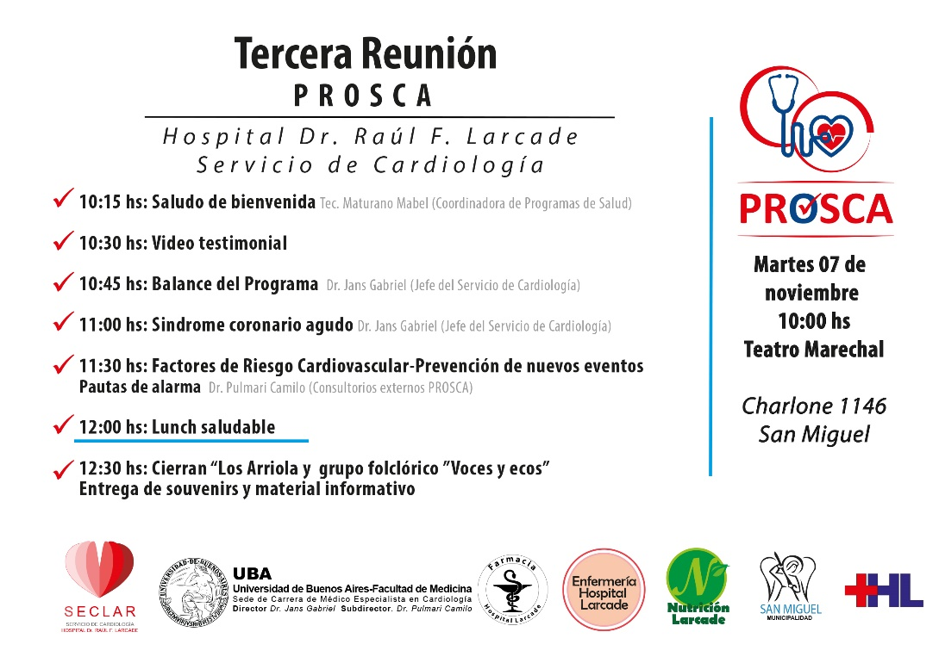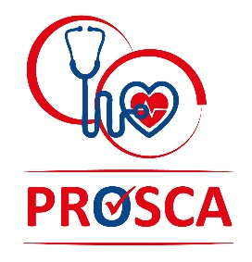

- Chobanian et al., 2003
- Rasmussen et al., 2007
- World Health Organization, 2003
- Jackevicius et al., 2007; Jackevicius et al., 2008
- Pharmacoepidemiol Drug Saf. 2015 Oct;24(10):1093-104.
- Eur J Prev Cardiol. 2016 Jun;23(9):975-85
- Jackevicius et al., 2002
- Mini et al., 2012
- Stone et al., 2001; Golin et al., 2002

