Health promotion in the Argentine Patagonia: Preventive musical tour of Dr. César Berenstein and “Los Guardianes del Botiquín” [the kit guardians]
Our motto is to promote health as an optimistic fact, instead of preventing diseases that takes us to the nightmare of picturing us as ill. They want to stimulate the population with changes of habit to improve their lives more than generating fear for the events we want to avoid.
Taking advantage of the World Heart Day, Dr. César Berenstein, cardiologist in El Bolsón (Río Negro province) together with two musician friends, Gabriel Lezcano and Marco Duarte, with whom he formed the band “Los Guardianes del Botiquín”, decided to go on tour for three days and almost 600km route, along the Comarca Andina of Parallel 42, in the Argentine Patagonia. They made seven talks in six localities of Río Negro province and Chubut, acting in the Public School N°140 Almafuerte of El Bolsón, in the Retirement Community of Bariloche, in Lehuen Clinics in Epuyén, in the Public Library of El Maitén, Multi Uses Salon of the municipality of Ñorquinco and the Hospital of Cholila. A snowstorm hindered us from ending out tour in Esquel. Most of these small localities have limited access to information and media; others are small towns of the Patagonian mountain range.
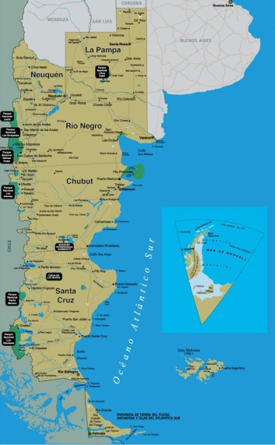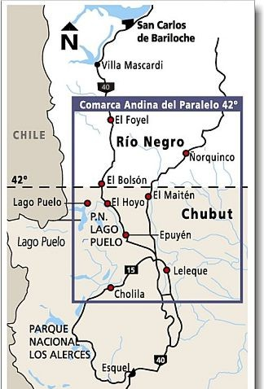
“25 by 25 Objective” of the World Heart Federation, the Sociedad Argentina de Cardiología – S.A.C [Argentine Cardiology society], “Corazon y Mujer” [Heart and Woman] of the S.A.C, “My heart, Your heart” of the Inter-American Society of Cardiology and “Cien Mil Corazones” [A hundred thousand hearts] from the Argentine Cardiology Federation and the Argentine Foundation of Biochemistry, were part of de campaigns. The themes presented in the meetings involved cardiovascular risk factors in Argentina, cardiovascular risks in woman, the benefits of the physical activity and the campaign “25 by 25 Objective”. When the meeting was over, the band played funny songs composed by them, related with the themes discussed during the meeting. They invited the locals to participate, so a cheerful and pleasant environment was created. Achieving two things, informing the participants and making them smile in their ways back home.

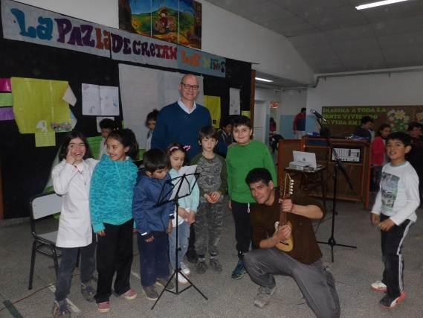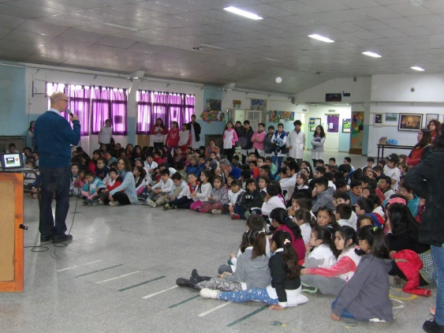
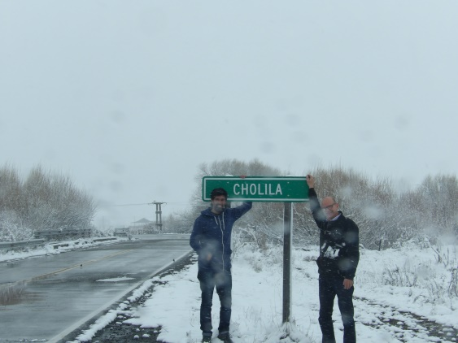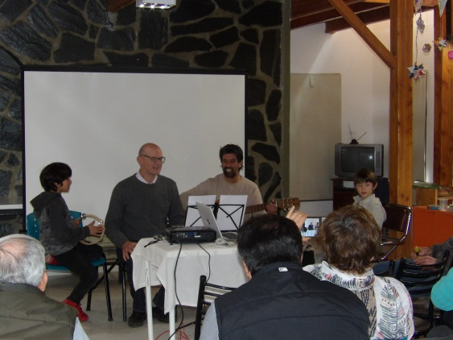
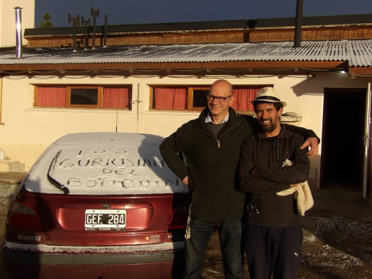
Dr. César Berenstein presented in the breakfast organized by the group “Woman and Heart” from the S.A.C and the American Heart Association, in the 44°edition of the Argentine Cardiology Congress the results of these meetings. As finishing touch Dr. Berenstein made Dr. Ricardo Migliore (President of the Argentine Cardiology Society), Dr. Verónica Volberg(Director of Woman and Heart group), Dr. Raúl Maltez (representative of Tierra del Fuego province) and the Graduate Mariana Fita (representative of Mar del Plata city) participate in the band. By this Dr. Berenstein managed to overcome the formality of the meeting without losing the focus of showing this different and unheard way of promoting health in our community.

The song especially composed for this meeting says as follows:

Mi madre es una mujer,
Mi hija es una mujer,
Quien amo es una mujer
También quien me enseñó a leer, otra mujer.

La quiero con su fuerza de mujer,
La quiero con su belleza de mujer
La quiero con su conciencia de mujer
Y con toda su experiencia de mujer.

Un beso, una caricia de mujer,
Una sonrisa, una palabra de mujer,
La imagen de un recuerdo de mujer,
Mi vida siempre a tu lado mi mujer.

Estribillo:
¿Sabes tu colesterol?, ¡mi mamita!
¿Y tu presión arterial?, ¡ay mi chiquita!
¿Sabes tu azúcar en sangre?, ¡ay mi huaynita!
Quizá no sepas lo que mide tu pancita.
Mujer, mi vida siempre a tu lado. Ni adelante ni atrás. ¡Siempre a tu lado!

My mother is a woman,
My daughter is a woman,
Who I love is a woman,
Also who taught me to read, is another woman.

I love her with her woman strength
I love her with her woman beauty,
I love her with her woman consciousness
And with all her experience of woman.

A kiss, a caress of woman,
A smile, a word of woman,
The picture if a woman memory,
Mi life always by your side my woman,

Chorus:
Do you know your cholesterol? , my mommy
And your blood pressure?, “ay mi little one”
Do you know your blood sugar levels?, “ay mi huaynita” ^{[1]}
Maybe you don’t know your belly measure.
Woman, my life always by your side.
Not forward, nor backwards. Always by your side!

[1] Huaynita: Comes from the word Wayna that is the name of the younger mountain in Machu Pichu. It is used to make analogies for the old and young people. In this case it makes reference to a young woman.
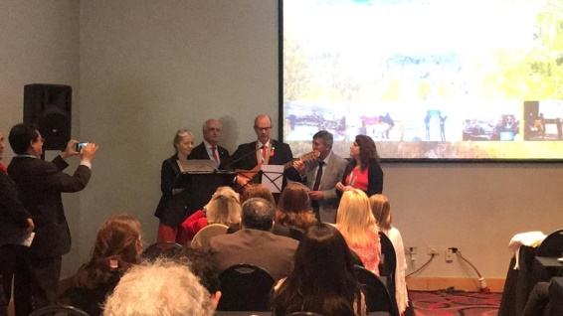
The proposal, without doubting, is that the health professionals look for the way of reaching to the target population with joyful and optimistic approaches, so promoting changes of habits for those who are healthier are lived as something celebratory, full of favourable emotions. Maybe one day health is accomplish as something contagious too.

